WEBD 1000 Google Devtools, Backgrounds, & Borders

**Website Development**

# Instructions

**You will complete the following steps in class and post the file(s) that you are asked to produce to the Brightspace dropbox for today’s in-class activity. If you need help with any step, ask the instructor.**

1. Create a new Word Document called “WEBD1000_Exercise10.docx” where you will paste all of the following screenshots.
2. Open a website that you are interested in in the Google Chrome Browser:
   1. Take a screenshot of the website and paste it into the Word document with a label of “**Before**”.
   2. Open the Chrome Developer Tools (DevTools) as demonstrated in class. **This time we will probably be adding new CSS rules rather then changing existing ones.**
   3. Change the site to have a background image tiled all over the web page (or at least most of the page if picking a smaller container).
   4. Take another screenshot with the DevTools open that shows the changes and paste it into the Word document with a label of “**Background Image**”.
   5. Change the site to only tile the background image in one direction.
   6. Take another screenshot with the DevTools open that shows the changes and paste it into the Word document with a label of “**One Direction** **Background Image**”.
3. Follow step 2 again to apply a visible border to another site where none existed. Label the after screenshot “**Visible Border**”.
4. Follow the step 2 yet again to apply a rounded border to another site where none existed. Label the after screenshot “**Rounded Border**”.
5. **See the examples on the next page for an idea of what the screenshots might look like.**
   1. You may want to use some shapes, like my arrows, in Word to point out the changes in the “After” images.
6. For an **added challenge**, you could try to apply all effects to one site at the same time and really “hack” their site! In that case you would only need one Before and one After screenshot.
7. Post the Word Document from Step 1 to the Brightspace Dropbox for the tenth in-class exercise in order to obtain credit for completing it.
8. That’s it.

# Highly Recommended

**There is no need to submit the results of this part of the activity and it will not be graded. However, it will be excellent practice for the upcoming assignment. If you need help with any step, ask the instructor.**

1. Complete the Tutorial 4 – Session 1 practice steps from the Textbook. The practice tutorial steps are in light brown or beige boxes within the chapters of the textbook. In this case the tutorial steps begin on page **HTML276** (Section 4-2) and conclude on page **HTML299** (Section 4-4d) for this Session.
2. Once the above Step is completed, validate **both** your tb_komatsu.html and tb_visual1.css files using the **appropriate** W3C CSS validation websites.

# Example: Background-image Applied to CBC.ca:

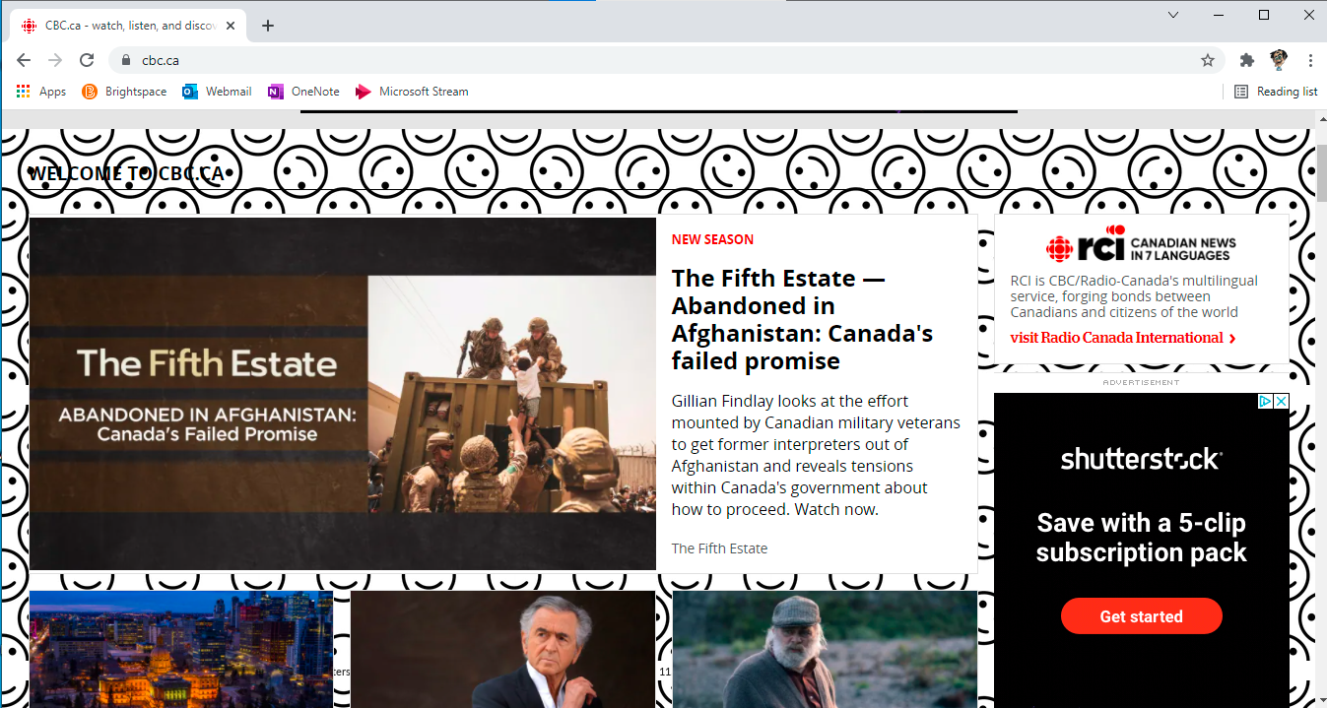

# Example: One Direction Background Image on CBC.ca

**Example: Visible Border on MSN**

**Example: Rounded Border on Wikipedia**

